

**LAB MIDTERM**

**SUBMITTED BY:** Kulsoom Khurshid

**REGISTRATION #:** SP20-BCS-044

**COURSE:** Operating System

**SUBMITTED TO:** MA’AM ZAHIDA WALIYAT

**Question no1:**

**Write a C program that perform following task using system calls (10)**

* **Makes a copy of a file**
* **Display the amount of free memory on your machine**
* **Display the amount of free storage on your machine**

**Solution:**

PROGRAM:

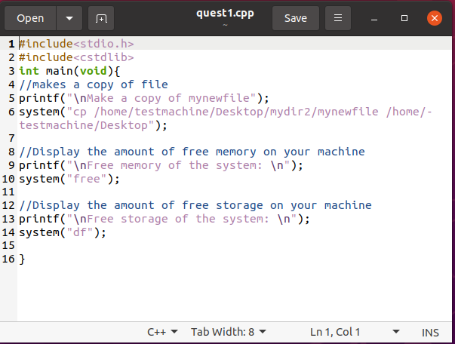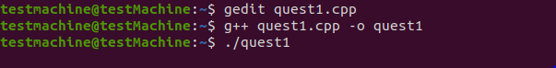

COPYING A FILE THROUGH PROGRAM:

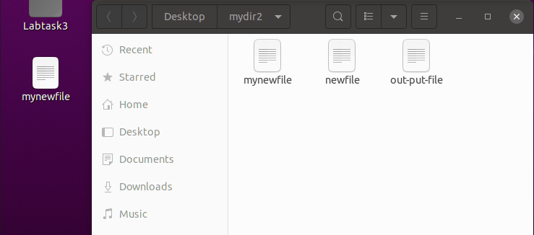

OUTPUT:

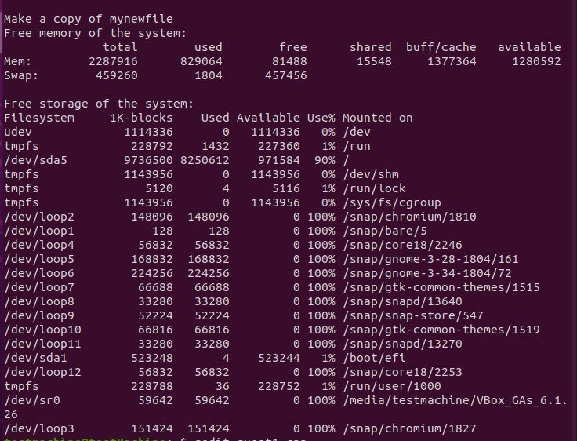

**Question no2:**

**Create two user accounts: tst1 and tst2 Logging in id: tst1, group users, with bash shell, home directory /home/tst1 Logging in id: tst2, group public, with bash shell, home directory home/tst2 For the two accounts set a password. Logging in as tst1 and copy /bin/ls into tst1 home directory as myls file. Change the owner of myls to tst1 and the permissions to 0710. What does this permission value mean? Logging in as tst2 and try to use /home/tst1/myls to list your current directory. Does it work? Create a new group labo with tst1 and tst2. Change the owner group of myls file to labo. Try again from tst2 account to execute /home/tst1/myls to list your current directory. Does it work?**

**Solution:**

CREATING USER TST1 AND TST2:

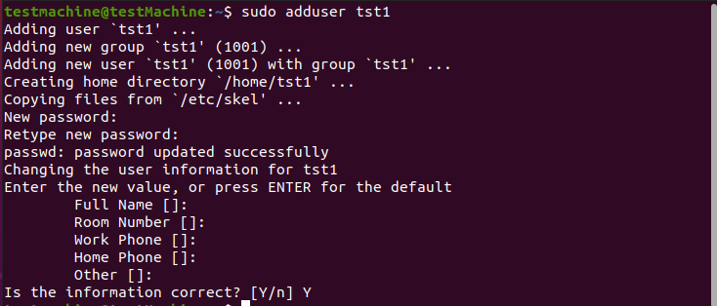

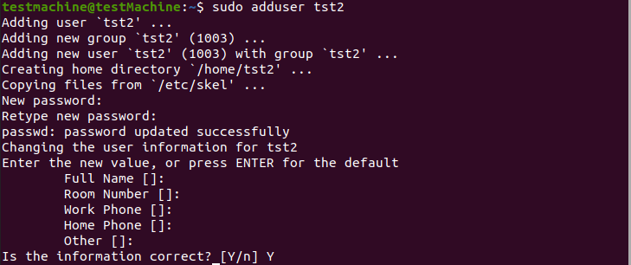

CHANGING THEIR PASSWORD:

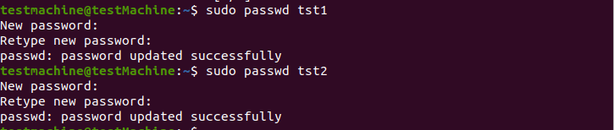

LOGIN AS TST1 AND COPY FILE:

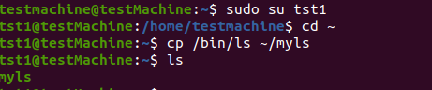

CHANGING OWNER AND PERMISSION:

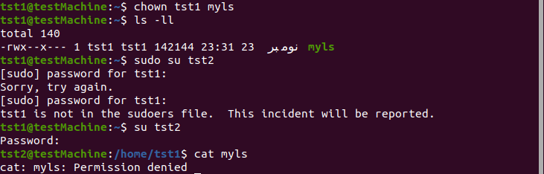

**Permission 0710 means owner can Read, Write and Execute. While groups can only execute.**

LOGIN AS TST2 AND TRY TO ACCESS MYLS:

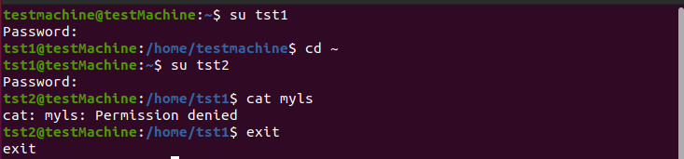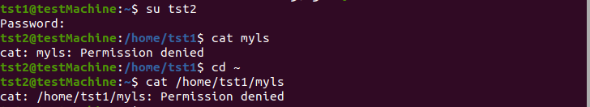

MAKING GROUP AND GIVING PERMISSION:

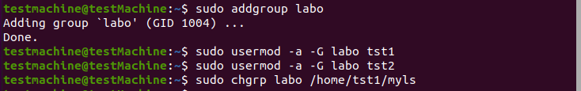

GIVING PERMISSION AND ACCESSING IT:

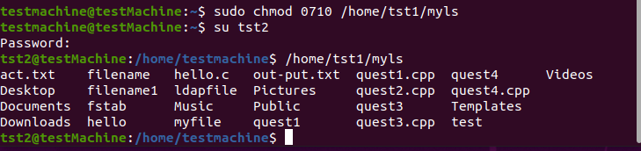

**Question no3:**

**Write a program that can be used to implement priority algorithm. Such that P2 run before P1. If there are P2, before P3 using semaphore.**

**Solution:**

PROGRAM:

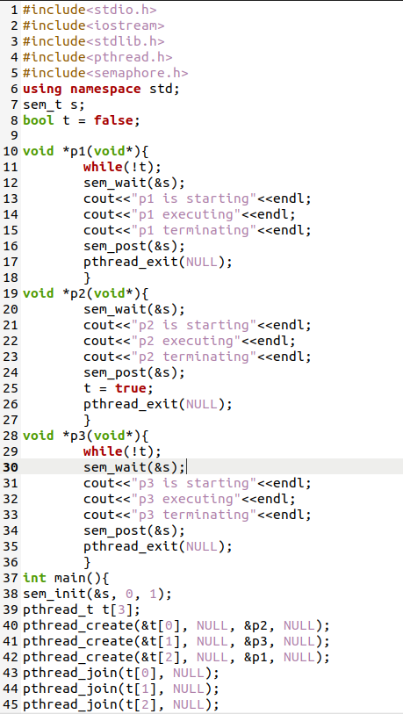

COMMANDS AND OUTPUT:

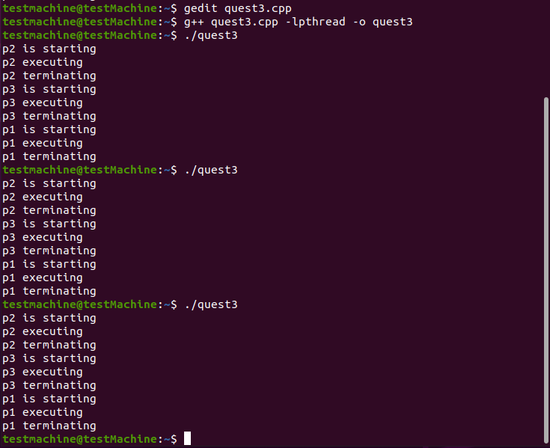

**Question no4:**

**Write a program that it accepts input numbers at command-line find the Average of input numbers.**

**Solution:**

PROGRAM:

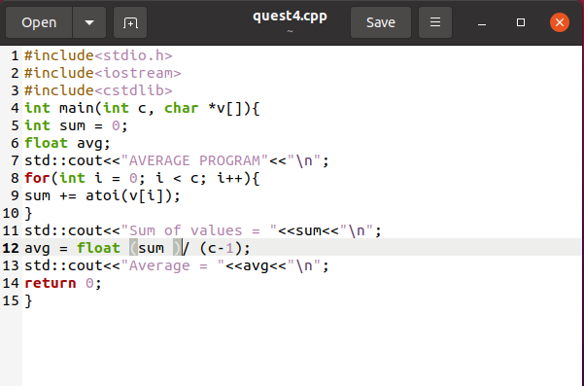

COMMANDS AND OUTPUT:

